Installation Notes for Pentaho Pivot4J

This document provides installation instructions that will enable you to use Pivot4J in the guided tutorial and assignment. The installation involves two parts. First, you need to install the proper version of the Java Runtime Environment. Then you can download and use Pivot4J for the guided tutorial and assignment.

# Java Runtime Environment Installation

You need to install the Java Runtime Environment (JRE) on your machine before you download and use Pivot4J. For Pivot4J on Windows, I have tested on JRE1.8 update 241.

Note that for Mac machines running OSX, you can use JRE8. Pivot4J executes properly under JRE8 for OS X machines.

You can obtain a free copy of Java Runtime Environment (JRE) from the website below. For Windows, you should install the 64 bit version unless you are still using a 32 bit version of Windows. This tutorial will assume that the default installation directory is used to install the JRE.

* https://www.oracle.com/technetwork/java/javase/downloads/jre8-downloads-2133155.html

# Pivot4J Download and Variable Setting

In this course, you should use the open source version of Pentaho Business Analytics Platform called the Pentaho Community Edition (Pentaho CE) which is available from the <https://community.hitachivantara.com/docs/DOC-1009931-downloads> website. This version does not need any installation and has no time limit. You only need to unzip the archive files to a designated folder before using the software. To download the Pentaho BI server and Pivot4J plugin, you should use this procedure for the community edition.

* In the community web page, you need to find the main download area for the Business Analytics Platform. Click the download link to start the download of the zip file for the platform. The current link is: <http://events.pentaho.com/CE-Download_Business-Analytics-Platform-ALL-OS.html>
* Unzip the downloaded zip file to any folder. The tutorial was written for pentaho-server-ce-8.2.0.0-342.zip. Note that the zip file name may not match this name as new community edition versions are released. In Windows, copy the folder *pentaho-server* to the folder C:\Program Files\Pentaho.
* To download the Pivot4J plug-in, you should navigate to the website: <http://www.pivot4j.org/download.html>. Scroll down and click on the .ZIP archive for the Pentaho BI Plugin stable release 0.9 (pivot4j-pentaho-0.9-plugin.zip OR pivot4j-pentaho-1.0-SNAPSHOT-plugin.zip). In Windows, unzip the archive folder “pivot4j” into the folder C:\Program Files\Pentaho\pentaho-server\pentaho-solutions\system.
* At this time, the latest version of the BI Server (8.2) supports the developmental snapshot (1.0) of Pivot4J (pivot4j-pentaho-1.0-SNAPSHOT-plugin.zip). BI Server 8.2 is compatible with the current JRE version (1.8).
* I recommend using the stable versions of the BI server and Pivot4J. The interface in the developmental snapshot of the Pivot4J is different than the interface in the stable release.
* For Windows, you also need to add a new variable in the windows Environment Variables. You need to go to the advanced system settings under system properties and click on Environment Variables. Click on New under System Variables. In the Variable name, you should enter “PENTAHO_JAVA_HOME”. In value of the variable name, you should enter “C:\Program Files\Java\jre1.8.0_241”. This folder value assumes that you installed JRE8 to the standard folder. If you installed JRE8 to a different folder, you should use that folder name.

# Pivot4J Usage

After this procedure is complete, you are ready to start the Pentaho BI Server and use the Pivot4J plugin. Even if you are not ready to work on the guided tutorial or assignment, you should start Pivot4J to ensure that your installation worked. Here are the steps to start the server and use the plugin.

* For Windows users, you should go to the folder C:\Program Files\Pentaho\pentaho-server and right click the **start-pentaho.bat** file and select Run as administrator. A command window will open showing some executing commands. Keep the command window (Figure 1) open. You can make a shortcut to this batch file to make it more convenient to launch the BI Server.
* For **Mac** users, you should use the terminal to navigate to the directory **pentaho-server/** and execute the set-pnetaho-env.sh file using the command “./set-pentaho-env.sh” You have to run this command only once. Then, execute the file start-pentaho.sh by using “./start-pentaho.sh”. You need to use only the last command to start pentaho for the next time.
* To start the web interface for the Pentaho BI server, you should open your browser and navigate to the address <http://localhost:8080/>.
* After you launch the browser interface, you should click on Login as an Evaluator. Use the Administrator account to login (Figure 2). The default page of the platform will appear as in Figure 3.
* When you are finished, you should close the browser or logout. Then you should execute the stop procedure. You should go to the folder C:\Program Files\Pentaho\pentaho-server and double click the **stop-pentaho.bat** file. A command window will open showing some executing commands. Then both command windows will close.

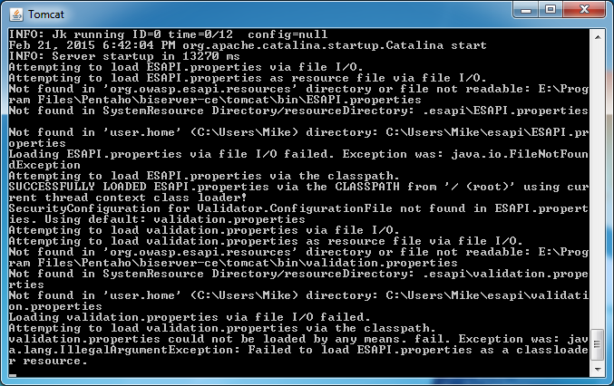

Figure 1: Windows Command Window for the BI Server

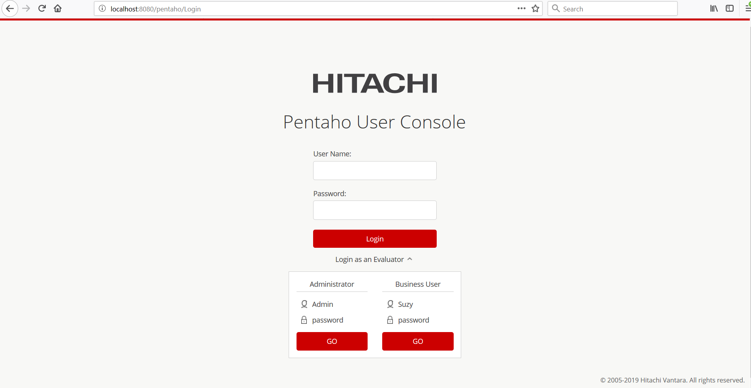Figure 2: User Console Login Window

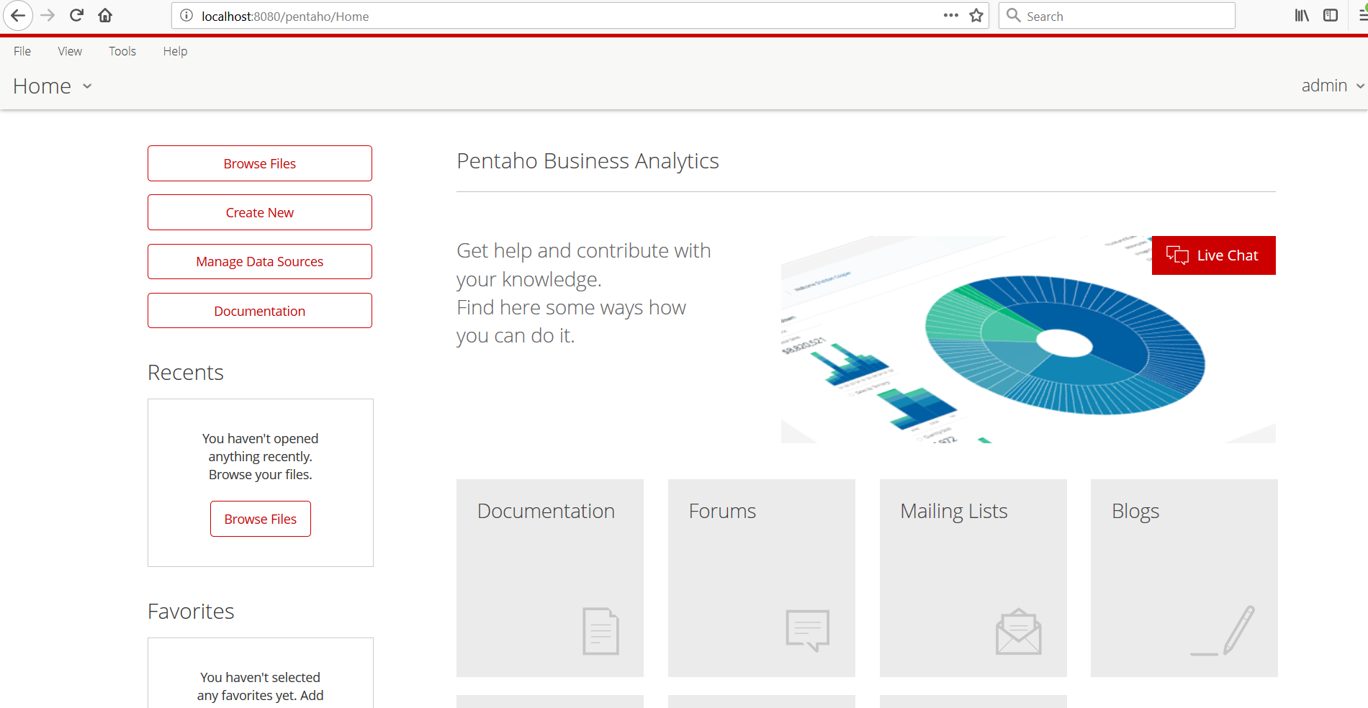Figure 3: Home Page of the User Console